**“SMART FARMING SYSTEM USING iOT”**

**A report submitted in partial fulfillment of the requirements**

**Of**

**Project Based Learning Course**

**In**

**Sixth Semester**

**By**

**1MS15IS139 Zeeshan Hameed**

**1MS15IS099 Sai Ashish Das**

**1MS15IS132 Vaibhav G N**

**1MS15IS122 Sirish P**

**Under the guidance of**

**Mohan Kumar**

Associate Professor

Dept. of ISE, RIT



RAMAIAH

Institute of Technology

**DEPARTMENT OF INFORMATION SCIENCE & ENGINEERING**

**RAMAIAH INSTITUTE OF TECHNOLOGY**

(AUTONOMOUS INSTITUTE AFFILIATED TO VTU)

VIDYA SOUDHA

M. S. RAMAIAH NAGAR, M. S. R. I. T. POST, BANGALORE – 560054

**2017-2018**

**Acknowledgment**

All sentences or passages quoted in this report from other people's work have been specifically acknowledged by clear cross-referencing to author, work and page(s). Any illustrations which are not the work of the authors of this report are not have been used (where possible) with the explicit permission of the originator and are specifically acknowledged. We thank our mentor Mr. Mohan Kumar to guide us throughout the project and enlightened us with great knowledge.

**Abstract**

India's population has reached beyond 1.3 billion and is still increasing day by day, in fact after 25-30 years there will be serious problems regarding food, hence it is necessary to develop and innovative the agricultural sector as soon as possible. Today, the farmers are suffering from the lack of rains and scarcity of water. The main objective of this system is to provide an automatic irrigation system which is powered by a smart solar system thereby saving time, money & power of the farmer. The traditional farmland irrigation techniques require manual intervention. With the automated technology of irrigation, the human intervention can be minimized. An automated irrigation system for efficient water management and intruder detection system has also been included. Soil parameters like soil moisture, temperature are measured and the sensed values are displayed on the system. Whenever there is a change in temperature and humidity of the surroundings these sensors sense the change and gives an interrupt signal to the IOT device. The solar panels continuously track the position of the sun to ensure maximum energy production. The intruder detection system is done with the help of PIR sensor where the birds and some other animals are repelled from entering into the field(to an extent). The ESP8266 wifi module has been used to establish a communication link between the farmer and the field. The farmer can access the server about the field condition anytime, anywhere thereby reducing the man power and time.

**Contents**

**1 Introduction** 5

1.1 Motivation 5

1.2 Scope 5

1.3 Objectives 6

1.4 Proposed Model 6

1.5 Organisation of Report 7

**2 Literature Review** 8

**3 System Analysis and Design** 10

3.1 System Analysis 10

3.1.1 Cost Analysis 10

3.1.2 Time Analysis 12

3.1.3 Power Analysis 13

3.2 System Design 13

**4 Modelling and Implementation** 14

4.1 Modelling 14

4.1.1 Use Case Diagram 14

4.1.2 Sequence Diagram 15

4.1.3 Class Diagram 15

4.1.4 Collaboration Diagram 16

4.2 Implementation 19

4.2.1 Requirements 19

4.2.2 Circuit Diagram 20

4.2.3 Real World Implementation 21

**5 Testing, Results and Discussion** 22

**6 Conclusion and Future Work** 23

**Bibliography 24**

**Chapter 1**

**Introduction**

1.1 Motivation

With the advent of evolution from apes, we humans have just been hunters and gatherers. This was the only known option for us to feed the living. But with the growth in number of survivors, the need for more food sparked the idea of what we now call ‘*agriculture*’. There are a number of definitions given to it but there are some that provide the real essence of it.

***Agriculture is the systematic raising of useful plants and livestock under the management of man***

*(Rimando, T.J.. 2004. Crop Science 1: Fundamentals of Crop Science. U.P. Los Baños: University Publications Office. p. 1).*

***Agriculture is the deliberate effort to modify a portion of Earth's surface through the cultivation of crops and the raising of livestock for sustenance or economic gain.***

*(Rubenstein, J.M. 2003. The Cultural Landscape: An Introduction to Human Geography. 7th ed. Upper Saddle River, NJ: Pearson Education, Inc. p. 496).*

Though agriculture provided us with a solution to feed all, it has now come to a halt due to the rapid growth of population again. Worldwide population is expected to grow to nearly 10 billion by 2050 - but agricultural lands won't be able to follow the same pace. The problem is clear: something has to change and that is motivates us. Agriculture as mentioned earlier in one of the definitions would come under the management of man, this is where we can improvise our approach. With the growth in technology we can now control almost anything with just a click and in most cases it is also possible to just sit back and let the computer do it all. This is all possible with the help of IoT. Internet of Things (IoT) is an ecosystem of connected physical objects that are accessible through the internet. The ‘thing’ in IoT could be a person with a heart monitor or an automobile with built-in-sensors, i.e. objects that have been assigned an IP address and have the ability to collect and transfer data over a network without manual assistance or intervention. The embedded technology in the objects helps them to interact with internal states or the external environment, which in turn affects the decisions taken.

Hence we can use this technology and incorporate with farming to catch up with the rapid pace of population growth. It would be better to call it “*Smart Farming*” as the entire idea is to make it smart by using technology to increase the productivity by minimizing the cost, power and time as much as possible.

1.2 Scope

Overpopulation causes global hunger, hence the scope of our idea is enormous.

Smart farming is a concept quickly catching on in the agricultural business. Offering high-precision crop control, useful data collection, and automated farming techniques, there are clearly many advantages a networked farm has to offer. A recent Beecham's report entitled Towards Smart Farming: Agriculture Embracing the IoT Vision predicts that food production must increase by 70 percent in the year 2050 in order to meet our estimated world population of 9.6 billion people. It also describes growing concerns about farming in the future: climate change, limited arable land, and costs/availability of fossil fuels. So, what's the solution? Smart farming.

Internet of Things can connect devices embedded in various systems to the internet. When devices/objects can represent themselves digitally, they can be controlled from anywhere. The connectivity then helps us capture more data from more places, ensuring more ways of increasing efficiency and improving safety and IoT security.

1.3 Objective

An article by Ashton published in the RFID Journal in 1999 said, “If we had computers that knew everything there was to know about things - using data they gathered without any help from us - we would be able to track and count everything, and greatly reduce waste, loss and cost. We would know when things needed replacing, repairing or recalling, and whether they were fresh or past their best. We need to empower computers with their own means of gathering information, so they can see, hear and smell the world for themselves, in all its random glory.” This is precisely what IoT platforms does for us. It enables devices/objects to observe, identify and understand a situation or the surroundings without being dependent on human help. Therefore the main objective of our project is “***To provide a Smart environment for farmers to work, that strives to increase the productivity and save time, money and power as much as possible by incorporating IoT technology into the farming system.”***

1.4 Proposed Model

The main objective of this system is to provide an automatic farming management system which is powered by a smart solar system thereby saving time, money & power of the farmer. The traditional farmland irrigation techniques require manual intervention. With the automated technology of irrigation, the human intervention can be minimized. An automated irrigation system for efficient water management and intruder detection system has also been included. Soil Parameters like soil moisture, pH, Humidity are measured and the pressure sensor and the sensed values are displayed on the system. Whenever there is a change in temperature and humidity of the surroundings these sensors sense the change and gives an interrupt signal to the IOT device. The solar panels continuously track the position of the sun to ensure maximum energy production. The intruder detection system is done with the help of PIR sensor where the birds are repelled from entering into the field. The GSM module has been used to establish a communication link between the farmer and the field. The farmer can access the server about the field condition anytime, anywhere thereby reducing the man power and time.

1.5 Organisation of Report

In order to explain the development of the smart farming system, the following sections are covered:

* **Literature Review** describes the study of the existing systems and techniques taken into account prior to development of the proposed system. It is used as a reference for us to maintain the standards of our system in the field of agriculture.
* **System Analysis and Design** provides a detailed walk through of the software engineering methodology adopted to implement the model, an overview of the system and the modules incorporated into the system
* **Modelling and Implementation** provides a deeper insight into the working of the model. The various modules and their interactions are depicted using relevant descriptive diagrams.
* **Testing** the model to ensure bug/error free model along with the **Results** obtained. This section of the report consists of all the testing and analysis made based on real time experiments made on the system. Then there is a **Discussion** that provides detailed analysis on quality assurance measures.
* **Conclusion** about the Results obtained after successfully running the model and **Future Scope** of the model is highlighted to ensure that the system is up to date and is able to provide the best results by continuing upgrading based on the available resources and also the determined requirements.

**Chapter 2**

**Literature Review**

2.1 Literature Review

The following section specifies the scholarly papers, contributions and substantive findings in context to our project. All the references below help us to carve our system into the best of its kind.

1. **Big Data in Smart Farming – A review** May 2017,

Authors: Sjaak Wolfert, Lan Ge, Cor Verdouw, Marc-Jeroen Bogaardt

Big Data is expected to have a large impact on Smart Farming and involves the whole supply chain. Smart sensors and devices produce big amounts of data that provide unprecedented decision-making capabilities. Big Data is expected to cause major shifts in roles and power relations among traditional and non-traditional players. Overnance (incl. data ownership, privacy, security) and business models are key issues to be addressed in future research.

2. **Internet of Things Platform for Smart Farming: Experiences and Lessons Learnt.**

Authors: Jayaraman , Yavari , Georgakopoulos , Morshed , Zaslavsky .

In this paper, we present the design of SmartFarmNet, an IoT-based platform that can automate the collection of environmental, soil, fertilisation, and irrigation data; automatically correlate such data and filter-out invalid data from the perspective of assessing crop performance; and compute crop forecasts and personalised crop recommendations for any particular farm. SmartFarmNet can integrate virtually any IoT device, including commercially available sensors, cameras, weather stations, etc., and store their data in the cloud for performance analysis and recommendations. An evaluation of the SmartFarmNet platform and our experiences and lessons learnt in developing this system concludes the paper. SmartFarmNet is the first and currently largest system in the world (in terms of the number of sensors attached, crops assessed, and users it supports) that provides crop performance analysis and recommendations.

3. **Smart farming using IOT**

Authors: Amandeep; Arshia Bhattacharjee; Paboni Das; Debjit Basu; Somudit Roy; Spandan Ghosh; Sayan Saha; Souvik Pain; Sourav Dey; T. K. Rana

2017 8th IEEE Annual Information Technology, Electronics and Mobile Communication Conference (IEMCON)

4. **Implement smart farm with IoT technology**

Authors: Chiyurl Yoon; Miyoung Huh; Shin-Gak Kang; Juyoung Park; Changkyu Lee

2018 20th International Conference on Advanced Communication Technology (ICACT)

Year: 2018

With the advent of Internet of Things (IoT) and industrialization, the development of Information Technology (IT) has led to various studies not only in industry but also in agriculture. Especially, IoT technology can overcome distance and place constraints of wired communication systems used in existing farms, and can expect agricultural IT development from automation of agricultural data collection. In this paper, smart farm system using low power Bluetooth and Low Power Wide Area Networks (LPWAN) communication modules including the wired communication network used in the existing farm was constructed. In addition, the system implements the monitoring and control functions using the MQ Telemetry Transport (MQTT) communication method, which is an IoT dedicated protocol, thereby enhancing the possibility of development of agricultural IoT.

5. **IoT based smart irrigation monitoring and controlling system**

Authors: Shweta B. Saraf; Dhanashri H. Gawali

2017 2nd IEEE International Conference on Recent Trends in Electronics, Information & Communication Technology (RTEICT)

Year: 2017

6. **Smart Farming – Improving Returns and Enhancing Environment**

Authors: IFA

**Chapter 3**

**System Analysis and Design**

3.1 System Analysis

Keeping in mind our objective we need to analyze what is to be done. The main problem a farmer faces is that the returns percentage is quite less. This means that his returns are not high as much as it should be. This leads to several problems. Many farmers become financially hit due to this and hence because of being unable to repay the debts they end in situations where they end their lives. This is quite common in countries where the global hunger index is high because of the rapid rate of population and the farmer failing to meet the high demands. To overcome this problem we have come up with our Smart Farming System using IOT. In the following section we analyze the farming technique and try to prove our objective.

3.1.1 Cost Analysis

Cost Analysis is essential for farm budgeting and planning enabling farmers to effectively compare and determine the profitability of various commodities; thereby creating an opportunity to identify and venture into farming as an enterprise based on current data.

The farmer has to consider a number of things when it comes to cost analysis of the farm.

By adopting the smart farming system there are a number of ways in which money can be saved.

First and foremost the entire system runs on solar power. Solar panels are installed that track the position of the sun at every degree. That is the system consists of a sun flower based solar system to track the position of the sun and this is done to ensure maximum input is captured and converted into energy that powers the system. The solar based system also recharges the power unit which will be able to run the entire system during night. This saves the farmers money to great extent. By doing so we have successfully been able to reduce the power cost by around ~10-12%.

Another way in which we can reduce the amount of money is by monitoring the amount of water that is being fed into the field. The system makes use of sensors to monitor the soil moisture so that the crops in the field our given water only when the moisture in the soil goes down below a particular value. This value varies with the type of soil. By incorporating this we will in turn be able to save around ~7-8% more when it comes to the cost being put into water management.

Apart from these the system also consists of a smart intruder detection which will help the farmer from any kind of intruders such as wild animals that would pose a potential danger to the crops. This also would help in reducing the cost of the farmers budget plan by around ~5% per year.

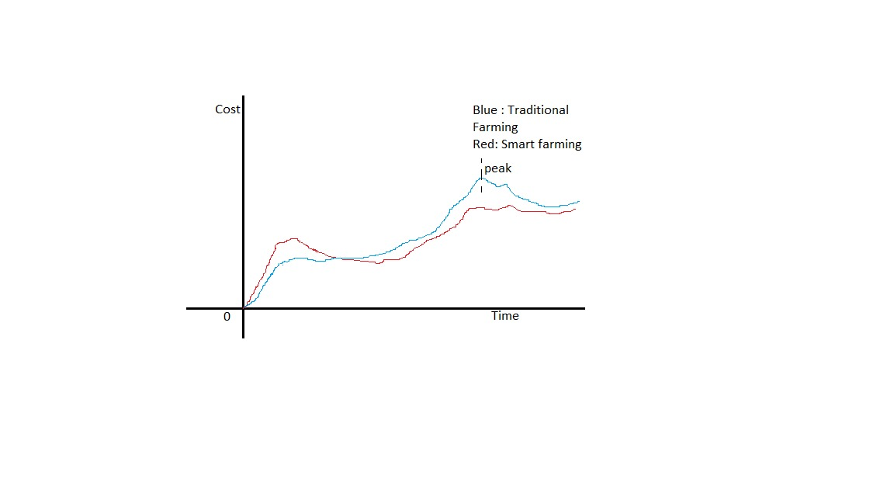

fig. Initial cost analysis

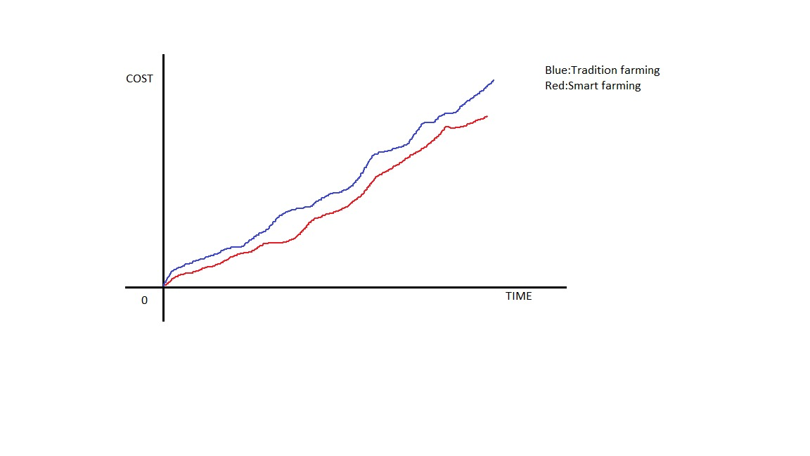

fig. Cost Analysis in the longrun

3.1.2 Time Analysis

A farmers time into field says about its dedication. But this restricts the farmer from being able to perform any of his other activities. We hence strive to make the system to be able to perform some tasks on its own such that the farmer is able to get save time for himself. This is where our smart farming system into picture. We have automated some important tasks that would help us save time. First we automate the drip irrigation method by including sensors that sense the soil moisture and let water into the field as and when needed. The amount of time saved here is less but it cannot be ignored. Some other ways in which time can be saved is by the intruder detection and avoidance system included in our system.

On the whole the an analysis of our system can conclude that time can be saved by around ~8% per annum.

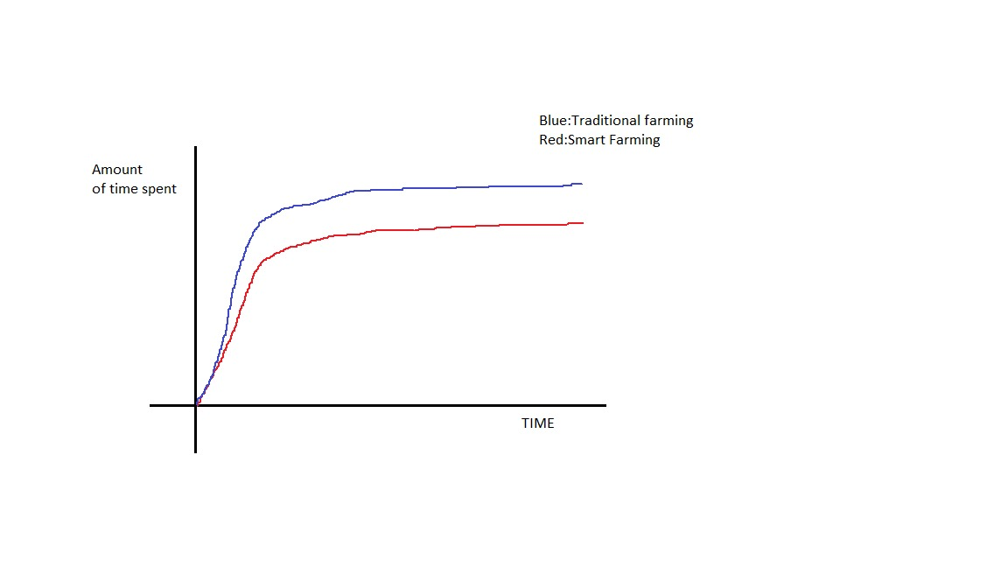

fig. Time Analysis

3.1.3 Power Analysis

Power here not only refers to power to run the system, but also the man power involved in farming. Analysis of power for the system has already been explained in the cost analysis section [3.2]. Now we will talk about how man power can be reduced or managed efficiently. A farmer alone cannot run an entire farm. He needs man power that will work for him on the field and also perform many other tasks. In our Smart Farming System with IOT technology we automate some vital tasks of farming. The smart drip irrigation system saves time and cost, but it also saves man power to some extent. The rate at which man power is saved can only be noticed at the yearly level. The more important aspect is that our system would open more career opportunities for people into the field of agriculture to perform tasks such as data analytics, field engineer and may be some more.

3.2 System Design

To be able to meet the objective of our system we need to design it in the most efficient way possible. The Smart Farming System using the IOT technology is designed in such a way that it is simple to install and also use. Our system consists of dividing the working of the farm into a different areas so that each part can be individually managed.

The field consisting of the crops will be installed with the soil moisture sensors, temperature sensors and also the PIR sensors. The Soil moisture sensor is used to sense the soil moisture and control the drip irrigation correspondingly. The temperature sensor will sense the temperature of the surrounding environment which will help us in weather analysis. The PIR sensors are installed around the field in specific locations which will detect the presence of any intruders and then required action is to be taken. The system also includes an efficient water management system to keep a check on the amount of water.

Apart from this the solar system based on the sunflower technology is installed in appropriate part of the field so as to facilitate best results. The power system to run our system in the field is achieved so by a two separate power units. One unit powers the system during the day while the other is recharged by the solar system and this second system is utilized to power the system during the night. This allows us to efficiently use and run the system to obtain the required results.

The main concept of our system is that it is smart and automated. Our entire system is to be controlled by the microcontroller or in simple words, a computer. The concept of IOT is

that it connects all the devices over the internet. We have designed the system in such way that all the data from the system is sent to a server. Data such as how much water was let out, the soil moisture , temperature, any intruder detection and much more is all sent from the system to the server. The server then is used to analyze the data and make appropriate outcomes. We can also control the system from the server to an extent. All this data can undergo deep analytics to be able to benefit the system in the long run. Predictions can be made by analyzing the data which can be very helpful in proving our objective.

**Chapter 4**

**Modelling and Implementation**

4.1 Modelling

The Smart Farm consists of a number of components including the field, solar unit and the watering system. In order to achieve the best results we need to model the system in the most efficient way. It is necessary to be able to represent the system in the form of systematic models such as the use-case, sequence, collaboration and various other diagrams. We accomplish this by defining the system based on certain models which are all explained in the upcoming sections.

4.1.1 Use Case Diagram

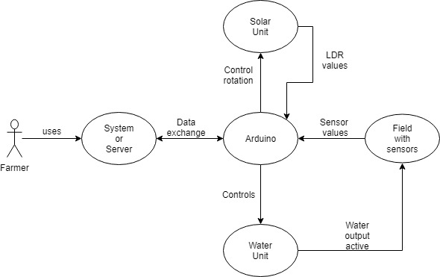A use case diagram is used to represent the different roles involved in a system. It specifies the operations of the system from the users point of view. Different components of the system are well depicted with the respective symbols and the corresponding roles involved in them. To further understand the use case diagram of the Smart Farm consider the following diagram.

fig. Use Case Diagram

The above given use case is self explanatory. The farmer can access the system, from he can keep an eye on all the progressing data being performed in the field. All these is controlled by the Arduino microcontroller. All the sensed values from the field are sent to the microcontroller which then performs the required operations such as controlling the sunflower based solar unit and the drip irrigation system.

4.1.2 Sequence Diagram

The sequence in which the operations will take place are all depicted in the sequence diagram. Every automated operation that is being performed in the field goes through a number of steps itself. These additional functionalities are all shown below. The sequence diagram given consist of the field, Arduino and the system as the intermediate nodes where all the operations are serialized. The sequence expected is provided in the following sections with the fig. 4.1.2 as the figure number.

4.1.3 Class Diagram

To be able to automatically control the entire system based on certain constraints, we need to write the code to perform it. We make use of the Arduino IDE (arduino.cc) to code, which provides us with a more user friendly environment to work. The entire code is to be uploaded onto the Arduino and hence the code is written all together. Arduino codes consists of two compulsory parts viz. setup and loop. There is no concept of class in our Arduino code and thus we can frame the class diagram as shown below.

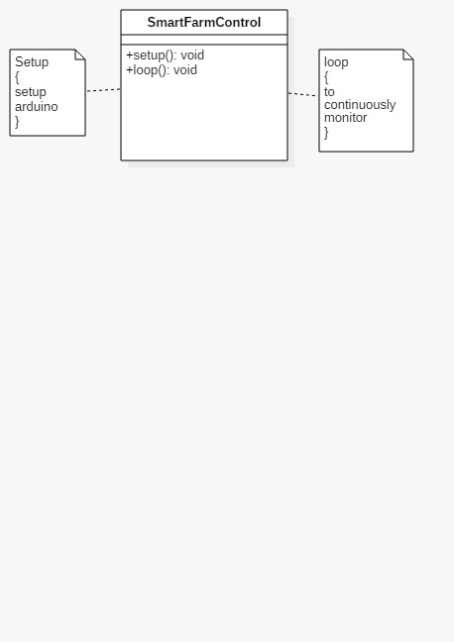

fig. Class Diagram

By referring the above figure it can be clearly understood why class diagrams in the arduino code cannot be completely expressive as they only consist of one code to refer to, that does need to call any other code except itself.

4.1.4 Collaboration Diagram

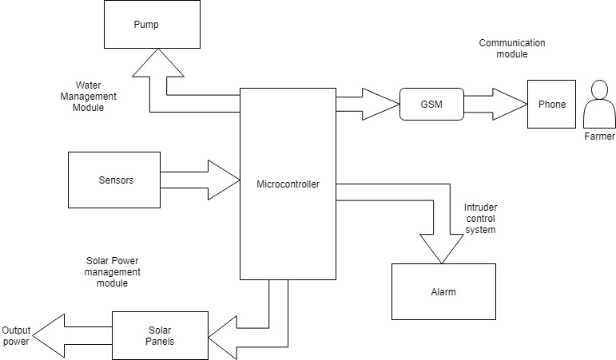A **collaboration diagram**, also called a **communication diagram** or interaction **diagram**, is an illustration of the relationships and interactions among software objects in the Unified Modelling Language (**UML**). To further explain this consider the diagram.

fig. Collaboration Diagram

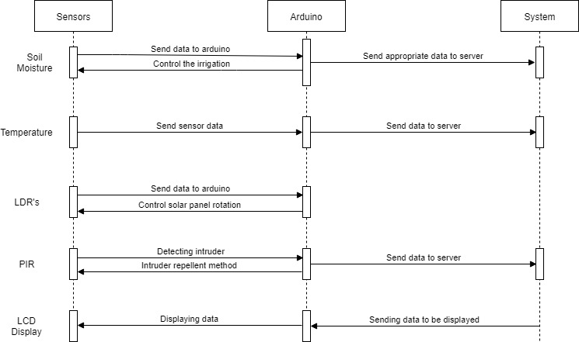

fig. 4.1.2 Sequence Diagram

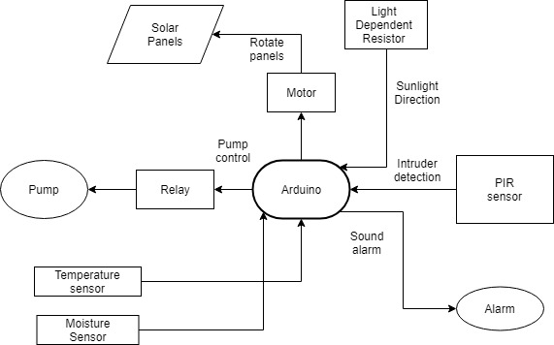4.2 Implementation

fig. Flow Diagram

The Smart farming system makes use of IOT technology to implement the desired operations. The entire system is run on the Arduino uno board which is a microcontroller based on the ATmega328. It has 14 digital **input/output pins** in which 6 can be used as **PWM outputs**, a 16 MHz ceramic resonator, an ICSP header, a USB connection, 6 analog inputs, a power jack and a **reset** button. Almost all the pins have been utilized to run the system operations. More detailed explanation on the implementation ahs been covered in following sections.

4.2.1 Requirements

The following is the list of all the components required to implement the Smart Farming using system IOT:

* Arduino Uno Board
* 5W Solar Panel
* 9g Servo Motor
* StepUp Boost
* Soil Moisture Sensor
* DHT Sensor
* PIR Sensor
* Submersible DC Motor
* Jump Wires
* Water Pipe
* LDR’s
* TP4056 Charging Module
* LiPo Batteries
* ESP8266 Wifi Module
* Buzzer
* LCD Display
* Relay Switch

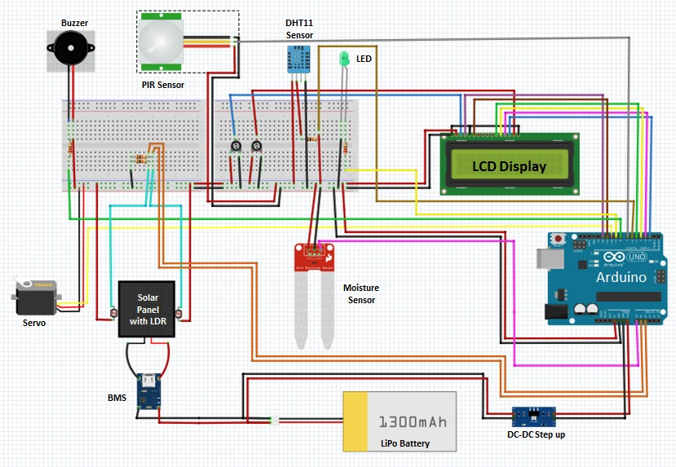

fig. Circuit Diagram

4.2.2 Real World Implementation

The Smart Farming System has to undergo an entire process of transformation to be able to satisfy the demands at that level. There would be a number of new additions to the system. On the whole the number of devices in the system would increase depending on the size of the field. In the small model, the soil moisture can be tested by examining only one soil moisture. But in real world since the area of the field is going to be very large we must define an efficient method to install our system so that we are able to justify our objective.

The number of soil moistures would not increase as much as expected but instead we make use of a smart method where only few soil moistures will be utilized to sense the soil moisture along an entire crop line. Not only does this decrease the number of sensors but it can also be used to get accurate results with the least required resources. Apart from this this the PIR sensors can be changed based on the area of the field and be installed in the most appropriate locations so as to be able to identify the intruder on any point on the field. To feed the crops with water from the tank or sump, we must install an AC motor unlike the arduino DC motor. In order to power the entire system the power unit would have to be suitable. The sunflower based solar unit which powers the entire system is to be scaled up to match the demands of the real world system. To do so we may have to make use of the concept of MOFSET scaling which can be utilized to control our system at larger scales and provide them with the required amount of power to run from the arduino board. By abiding to the specified conditions anyone would be able to successfully install an efficient Smart Farming System using IOT.

**Chapter 5**

**Testing, Results and Discussion**

To be abled to make the system error proof and ensure that it would perform as expected we need to test it in many scenarios. We divide the testing into several parts so that it would be better to rectify errors in the sub divided components and then integrate these parts to perform the system run so that the least or no errors are expected. We start off by testing the sensors individually and then by integrating them together. Then based on these values we perform the various operations.

The soil moisture sensor is used to sense the amount of water in the soil and based on this value it is decide whether the water is fed into the field or not. The value on which this is based depends on the type of the soil. The soil we have used for our system trial works on the value of around ~520. If the sensed value goes below this value then the drip irrigation is activated. Once the value reaches around 650 it stops. This value is determined by performing several experimental tests.

Similarly the PIR sensor is used to sense the presence of any intruder in the field. This is achieved by performing tests so that we can determine the exact area which the sensor has to cover to avoid including the areas of the neighboring fields.

The results from the above tests are utilized to produce a system that defines our objective best. As per plans we had to make the project a viable one. We were able to successively transmit, receive and record the data on our server. The data was available for transmission through the ESP8266 wifi module which would utilize the available wifi connections and exchange the encrypted messages. The data sent consisted of the readings of the moisture, the temperature, number of times water is let out, intruder detected details and much more. This same data was also recorded and made to be displayed onto the on field LCD display.

**Chapter 6**

**Conclusion and Future Work**

All observations and experimental tests proves that project is a complete solution to field activities, irrigation problems, and storage problems using iot, smart irrigation system and a smart warehouse management system respectively. Implementation of such a system in the field can definitely help to improve the yield of the crops and overall production.

We can add many additional features to the system based on the demands. An extra water management system can be installed to monitor the water levels and be optimized to get the most efficient results. The current Smart farming system consists of only the intruder detection but we can also install a system to be able to repel the intruder to an extent by taking the proper action.

The farm can also be integrated with smart fertilizer and pesticide feeding system which would run on satisfying certain constraints. Drones can be included to monitor the entire farm and report to the server so that the farmer can monitor the farm from his cabin itself. Data analytics can be improved and be made to produce better outputs so that the farmer can be prepared for future. The entire farming system can be expanded into other fields such as cattle farming and then strive to improvise it to obtain the required best results and satisfy the demands of the rapidly growing population.

**Bibliography**

**Introduction to agriculture :-**

http://www.cropsreview.com/what-is-agriculture.html

**Literature Survey :-**

https://ieeexplore.ieee.org/search/searchresult.jsp?queryText=smart%20farming%20using%20iot&pageNumber=2&newsearch=true

https://www.sciencedirect.com/science/article/pii/S0308521X16303754

**Smart Farming Improving farm returns and enhancing environment :-**

https://www.ifa.ie/wp-content/uploads/2017/10/IFA-Smart-Farming-Progress-Report-2017.pdf

**Circuit Diagram :-**

http://fritzing.org/